

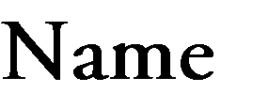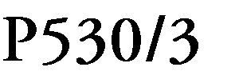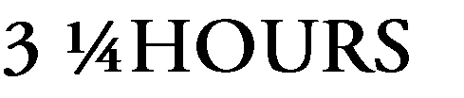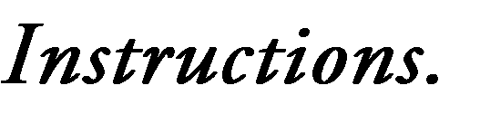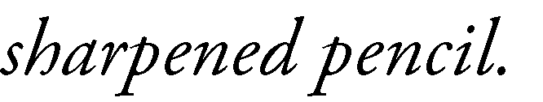

|  |  |
| --- | --- |
|  |  |
|  |  |
|  |  |
|  |  |
|  |  |



(a) Study the external features of the specimen and list **three** observable features of the head that enable the specimen to colonize land. *(03 marks)*









b(i) Identify **two** supportive structures on the specimen. Examine and describe each one of them fully. (4marks)

……………………………………………………………………………………………………

……………………………………………………………………………………………………

……………………………………………………………………………………………………

……………………………………………………………………………………………………

(ii) How are the supportive structure suited for their function? (3marks)

……………………………………………………………………………………………………

……………………………………………………………………………………………………

……………………………………………………………………………………………………

c) Dissect the specimen to display blood vessels which;

1. supply the left side of the head, neck and thoracic region,
2. drain the right side of the head, neck and fore limb as well as the first half of the abdominal region of the specimen back to the heart.

Draw and label (i) and (ii) above in one diagram. (*30marks*)

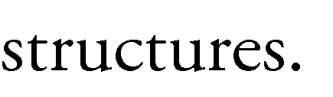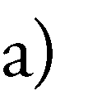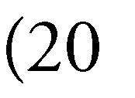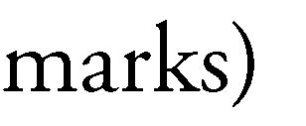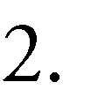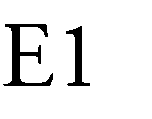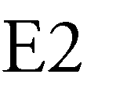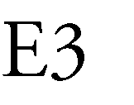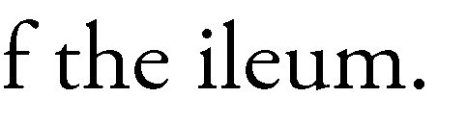

|  |  |
| --- | --- |
|  |  |
|  |  |
|  |
|  |
|  |
|  |  |
|  |
|  |
|  |
|  |  |
|  |  |
|  |
|  |

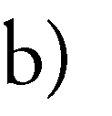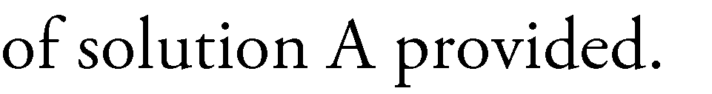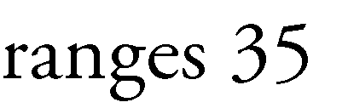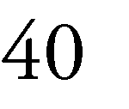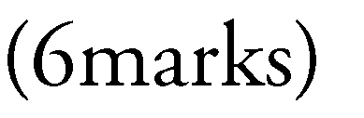

|  |  |  |  |
| --- | --- | --- | --- |
|  |  |  |  |
|  |  |  |  |
|  |  |  |
|  |  |  |  |
|  |  |  |
|  |  |  |  |
|  |  |  |

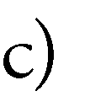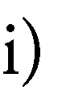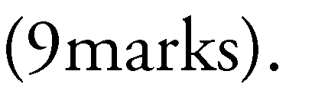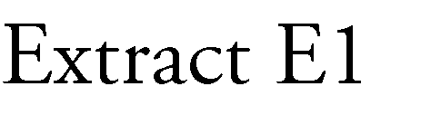

Extract 2

……………………………………………………………………………………………………

……………………………………………………………………………………………………

.…………………………………………………………………………………………………...

Extract 3

……………………………………………………………………………………………………

……………………………………………………………………………………………………

……………………………………………………………………………………………………

iii) Account for the difference, if any, in the observations for suspension E and extract E1.

……………………………………………………………………………………………………

……………………………………………………………………………………………………

…………………………………………………………………………………………………………………………………………………………………………………………………………

d) From your results in table 2,

(i) Suggest **two** reasons for addition of solution chloride to the contents of the tubes.(2marks)

1

……………………………………………………………………………………………………

……………………………………………………………………………………………………

2

…………………………………………………………………………………………………………………………………………………………………………………………………………

ii) Suggest the part of the alimentary canal (E1, E2 or E3) from which solution A can be obtained. Give **two** reasons for your answer. (3marks)

part

……………………………………………………………………………………………………

Reasons

……………………………………………………………………………………………………

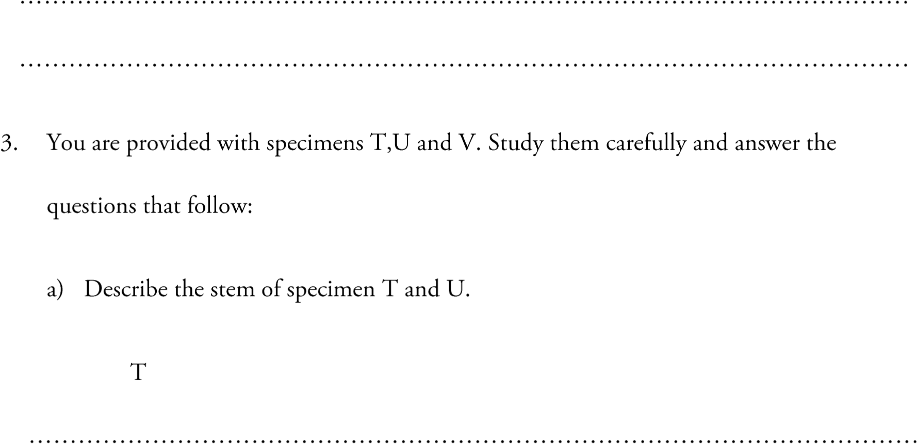

**T**

……………………………………………………………………………………………………

……………………………………………………………………………………………………

……………………………………………………………………………………………………

**U**

……………………………………………………………………………………………………………………………………………………………………………………………………………………………………………………………………………………………………………...

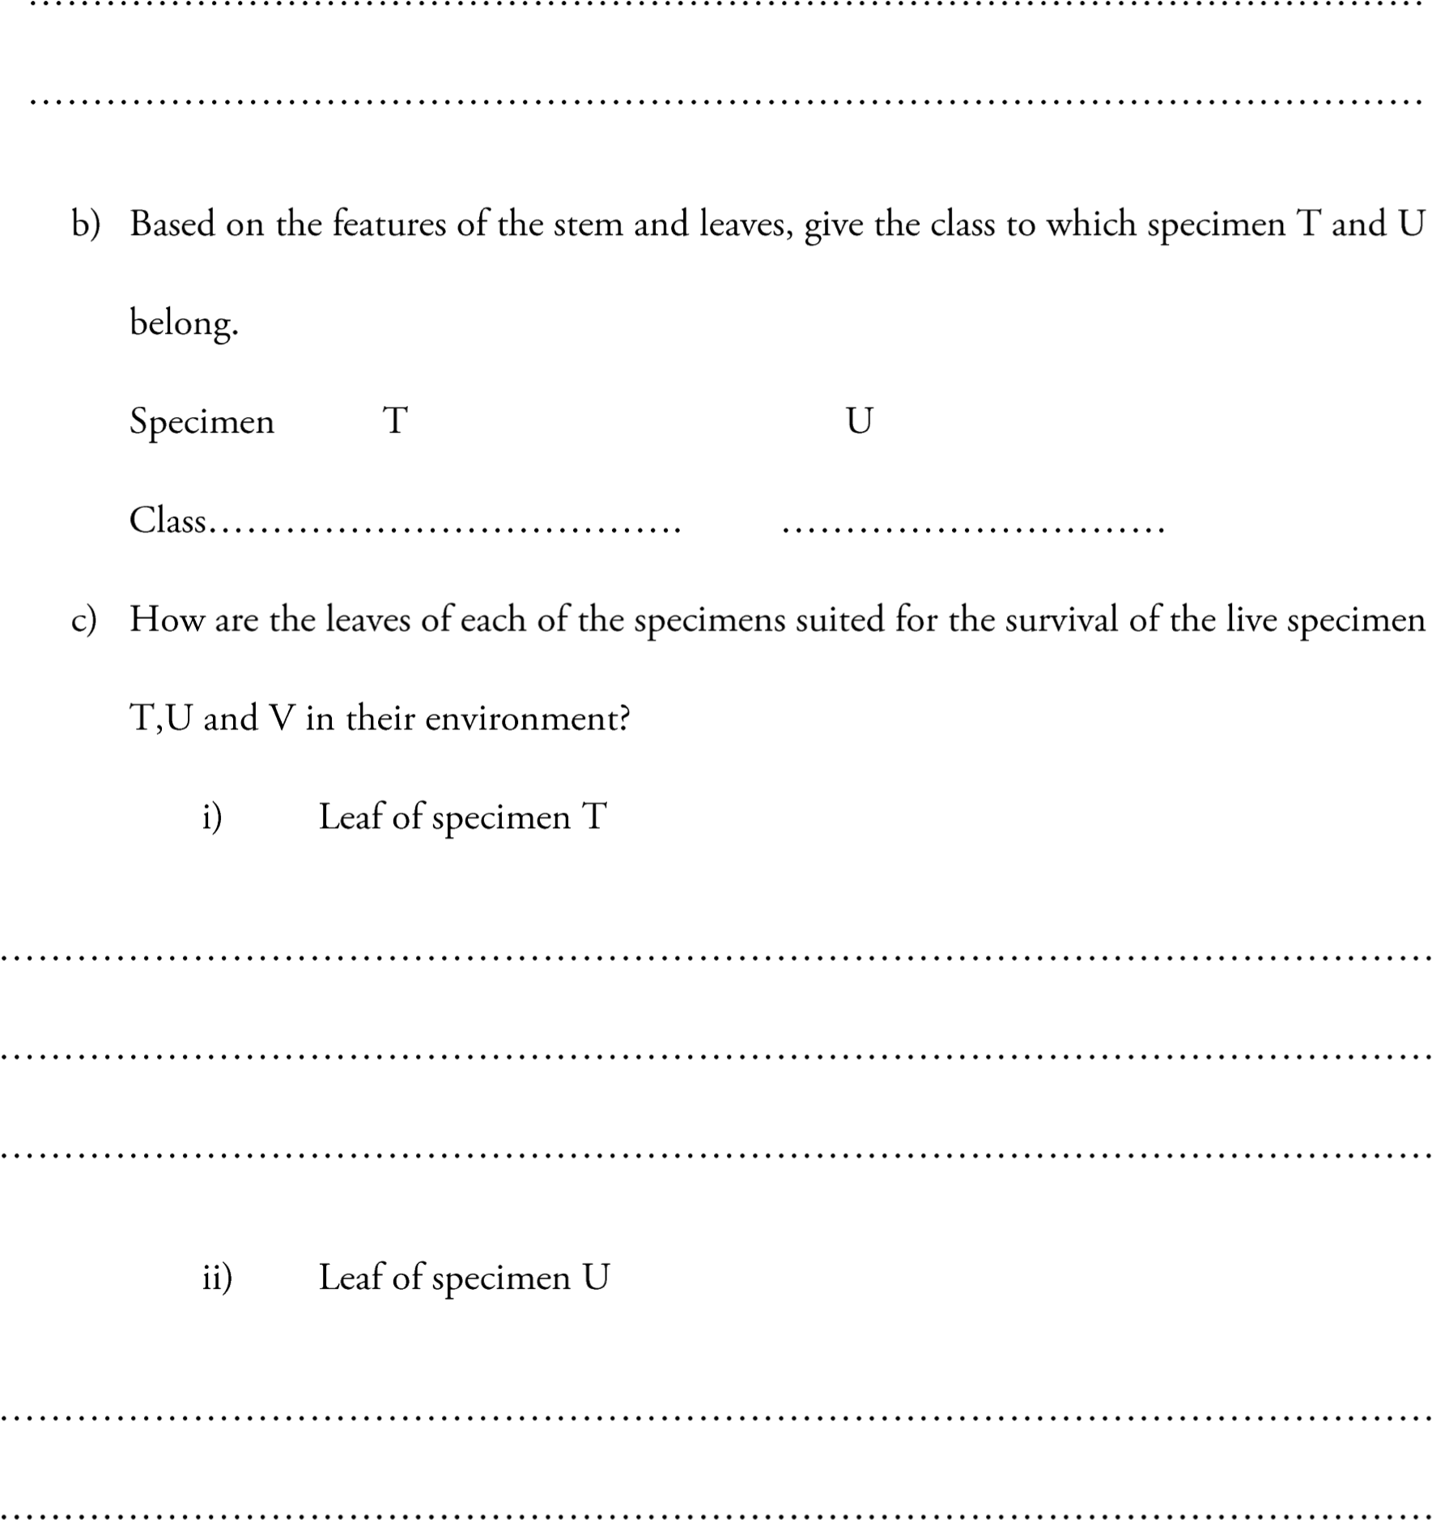

iii) Leaf of specimen V

……………………………………………………………………………………………………

……………………………………………………………………………………………………

……………………………………………………………………………………………………

d) How is specimen V suited to live in its habitat?

……………………………………………………………………………………………………

……………………………………………………………………………………………………

……………………………………………………………………………………………………

